**Factors Affecting an Equilibrium System**

Chemical equilibrium was studied by French chemist Henri Le Châtelier (1850-1936), and his description of how a system at equilibrium responds to a change in conditions has become known as [**Le Châtelier’s principle**](https://www.howtopronounce.com/le-chatelier-principle):

*When a chemical system that is at equilibrium is disturbed by a stress, the system will respond by attempting to counteract that stress until equilibrium is re-established*.

Another way of saying this is - changes to the conditions of a system at equilibrium can disturb that equilibrium. When this occurs, the system reacts in such a way to reverse the change and to restore the equilibrium.

Stresses or changes to a chemical system include changes in the

1. Concentrations of reactants or products,
2. Temperature of the system,
3. Pressure of the system. (Actually, this is only true if the pressure change causes a concentration change – pressure does not affect solids and liquids – so pressure only affects gases in an equilibrium)

In each case, the change to the equilibrium will cause either the forward or the reverse reaction to increase in rate. For example, if a system is at equilibrium and more reactants are added (conc of reactants increases), the rate of the forward reaction will naturally increase in rate and be faster than the reverse reaction (equilibrium is “disturbed”).

This increase in the rate of the forward reaction will cause the concentration of the products to increase over time, and also decrease the concentrations of the reactants over time. Thus, the reverse reaction will speed up as more products are made, and the initially faster forward reaction will slow down, as the concentration of reactants decreases. Eventually the reverse reaction speeds up to a point where it is again equal to the slowing forward reaction and equilibrium is re-established. The forward and reverse reactions will both be slightly faster than before, but both will be equal again, = equilibrium.

**Note:** There is often some specific language used with equilibrium. Equilibriums can be said to “**favour**”, “**lie**”, or “**shift**”. The first two of these terms refers to the relative concentrations of the reactants or products. For example, an equilibrium where there is a high concentration of reactants and a low concentration of products is said to **favour** the reactants, or to **lie** well to the left. The last term (shift) refers to what happens as the equilibrium responds to being disturbed. The changes in concentration that occur after an equilibrium is subjected to stress or change. If the concentration of the reactants has increased, the equilibrium has “**shifted**” to the left, or shifted in favour of the reactants. The opposite term is used if the concentration of the products has increased (shifted to the right or in favour of the products)

**The effect of Concentration Changes on Equilibrium**

A change in the concentration of one of the substances in an equilibrium system typically involves either the addition or the removal of one of the reactants or products *(however, watch out for the addition of a substance which reacts with (therefore reduces) one of your reactants or products)*.

Consider the Haber-Bosch process for the industrial production of ammonia from nitrogen and hydrogen gases:

N2(g) + 3H2(g) ⇌ 2NH3(g)

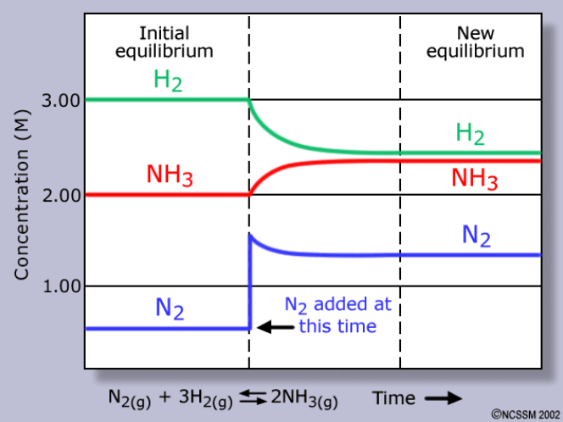

**Δ~3**

**Δ~2**

**Δ~1**



Le Chatelier’s principle states that if the concentration of one substance in a system is increased, the system will respond to reduce the concentration of that substance (by increasing the rate of the forward or reverse reaction).

For example, say more N2 is added to the N2/H2/NH3 system at equilibrium (see blue line on graph). If the change is an increased concentration of N2, the equilibrium will shift in such a way to reduce the concentration of N2. Thus, the forward reaction will be favoured because the forward reaction uses up N2 and converts it to NH3. Therefore, the forward reaction speeds up. Since the forward and reverse rates are no longer equal, the system is no longer at equilibrium, and there will be a net shift to the right (increasing [NH3]) and the reverse reaction also increases in rate. Overall, the shift in equilibrium means that the concentration of NH3 increases, while the concentrations of N2 and H2 decrease. After some time passes, equilibrium is re-established with new concentrations of all three substances. As illustrated in the figure [on](https://www.ck12.org/book/CK-12-Chemistry-Intermediate/section/19.2/#x-ck12-SW50Q2gtMTktMDMtUmVzdG9yaW5nLUVxdWlsaWJyaXVt) the right, the new concentration of NH3 is higher than it was originally. The new concentration of H2 is lower. The final concentration of N2 is higher than it was in the original equilibrium, but lower than it was immediately after the addition of N2 that disturbed the original equilibrium.

**Checking for Understanding**

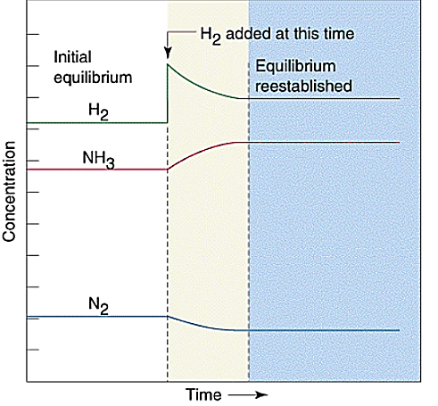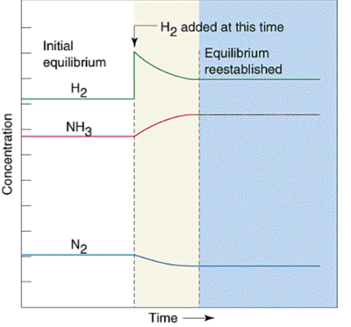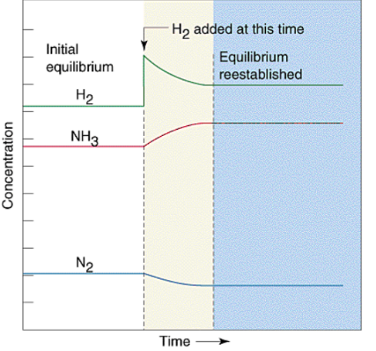

NH3

H2

N2

NH3

0 5 8 min

Conversely, if more NH3 were added, the reverse reaction would be favoured. This change to the Haber equilibrium is shown on the left. Predict what changes would occur to the concentrations of each reagent as equilibrium is re-established. That is, sketch the lines representing the concentration of each reagent from 5 mins onwards, assuming that equilibrium is re-established at 8 mins.

Remember to get the ratio (coefficients in equation) of the changes correct (approximatly – no need to be exact: 1N2:3H2:2NH3)

**Reduction in concentration - Checking for Understanding**

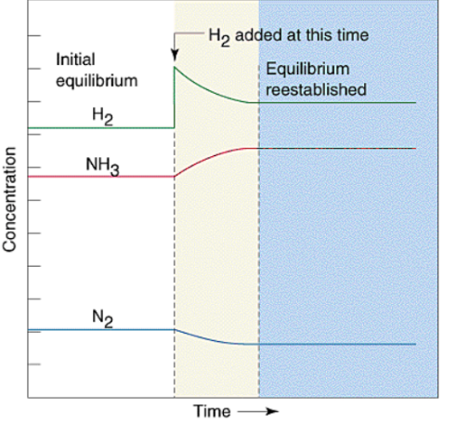

NH3

H2

N2

H2

removed

0 5 8 min

An equilibrium can also be changed by the removal of one of the substances. If the concentration of a substance is decreased, the system will respond by favouring the reaction that increases it’s concentration. In the industrial Haber-Bosch process, if H2 is removed from the equilibrium system, the equilibrium will shift and be re-established. Predict the changes in concentration as the equilibrium is re-established. Complete the following sentence describing this:

The concentration(s) of ________ will decrease, and the concentration(s) of _________ will increase, as the equilibrium is re-established.

The effects of changes in concentration on a system at equilibrium are summarized below.

|  |  |  |
| --- | --- | --- |
| **Change to the Equilibrium** | **Effect on the Equilibrium** | **Changes to re-establish Equilibrium** |
| addition of reactant | forward reaction favoured | [reactants]**↓**  [Products]**↑** |
| addition of product | reverse reaction favoured | [reactants]**↑**  [Products]**↓** |
| removal of reactant | reverse reaction favoured | [reactants]**↑**  [Products]**↓** |
| removal of product | forward reaction favoured | [reactants]**↓** [Products]**↑** |

**Temperature** **changes on equilibrium**

Temperature is also a factor which can affect equilibrium. Temperature change is the one factor which can also change the equilibrium constant (more on this in the next section, just remember this very important fact for now).

As an example, consider the equation for the Haber-Bosch process as written below as a thermochemical equation:

N2(g) + 3H2(g) ⇌ 2NH3(g) ΔH= -91 kJ (exothermic reaction = heat is a product)

OR N2(g) + 3H2(g) ⇌ 2NH3(g) + 91kJ

The forward reaction is exothermic (releases heat). The reverse reaction is endothermic (absorbs heat). This simple understanding allows you to predict the changes to equilibrium when the temp changes.

If a system at equilibrium is heated and the temperature increased, Le Chatelier’s principle states the equilibrium will shift to favour the reaction that absorbs the additional heat and reduce the temp. In the reaction above, that is the reverse reaction (the endothermic one, where heat is absorbed). This means the reactants are favoured and their concentrations will increase. Thus, for the Haber-Bosch process, an increase in temperature favours the reverse reaction in order to decrease the temperature; and the concentration of NH3 in the system decreases, while the concentrations of N2 and H2 increase. Note, the increases and decreases in the diagram are approximately consistent with the coefficients of the reagents.



**H2**



**NH3**

**N2**

**Temp increase at this point**

Conversely, if a system at equilibrium is cooled and the temperature decreased, the equilibrium will favour the direction of the reaction that releases heat and increases the temperature: the exothermic direction is favoured. For the Haber-Bosch process, a decrease in temperature favours the forward reaction. The concentration of NH3 in the system increases, while the concentrations of N2 and H2 decrease.

The NO2/N2O4 equilibrium is often cited in equilibrium dicusssions as N2O4 is a colourless gas and NO2 is a brown gas. The reaction is shown below

N2O4(g) + heat ⇌ 2 NO2(g)

**Colourless** **brown**

When N2O4 breaks down into NO2, heat is absorbed according to the forward reaction above. Therefore, an increase in the temperature of the system will favour the forward reaction, while a decrease in temperature will favour the reverse reaction. By changing the temperature, the equilibrium between colourless N2O4 and brown NO2 can be manipulated, resulting in a visible colour change.

**Checking for Understanding**

Complete the sketches of equilibrium concentration below:

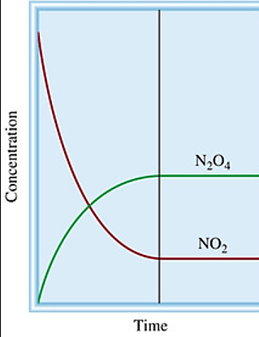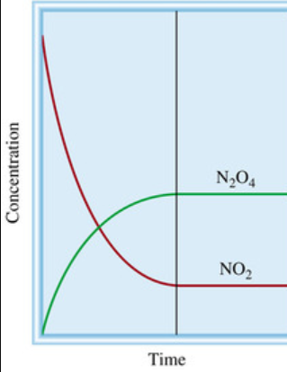

Temperature increase at this time



Temperature decrease at this time

The effects of changes in Temperature on a system at equilibrium are summarized below.

|  |  |  |
| --- | --- | --- |
| **Change to the Equilibrium** | **Effect on the Equilibrium** | **Changes to re-establish Equilibrium** |
| **Forward** reaction is **exothermic** (-ve ΔH) | | |
| Increase in temperature | Reverse (Endothermic) Rn favoured | [reactants]**↑**  [Products]**↓** |
| Decrease in temperature | Forward (Exothermic) Rn favoured | [reactants]**↓**  [Products]**↑** |
| **Forward** reaction is **endothermic** (+ve ΔH) | | |
| Increase in temperature | Endothermic reaction favoured | [reactants]**↓**  [Products]**↑** |
| Decrease in temperature | Exothermic reaction favoured | [reactants]**↑**  [Products]**↓** |

**Pressure changes on Equilibrium**

Only equilibrium reactions which involve gases are affected by pressure changes. Any equilibrium that does not involve a gas will not be affected by changes to pressure. This is because a change in the pressure on a liquid or a solid has a negligible effect on its concentration. Additionally, changing the pressure by adding an inert gas does not have any effect on the equilibrium. Only pressure changes which involve changes in volume will affect equilibria.

Gases on the other hand, can have their volume (and thus concentration) changed significantly by changes in pressure. For this reason, changes in pressure for gases at equilibrium is actually about the changes in concentration of the gases. However, the logic is the same and explaining equilibrium shift using pressure is easier – so the remainder of this text will discuss pressure changes without considering concentration.

On the far left, the reaction system contains primarily N2 and H2, with only one molecule of NH3 present. As the piston is pushed inward, the pressure of the system increases according to Boyle’s

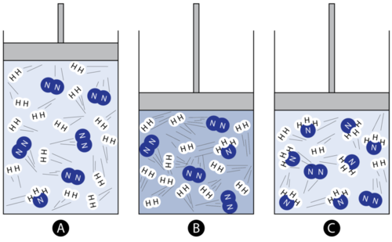

**Equilibrium favours the reactants**

**Pressure is increased**

**Equilibrium is re-established**

Law (P/V = constant). This is a stress to the equilibrium. In the middle image, the same number of molecules are now confined to a smaller space, so the pressure has increased. According to Le Châtelier’s principle, the system responds in order to counteract the stress...or reduce the pressure. Thus, three molecules of N2 combine with nine molecules of H2 to form six molecules of NH3. This is an overall decrease in the number of gas molecules in the system leading to a decrease in pressure, which counteracts the original stress of a pressure increase.

A decrease in pressure on the above system could be achieved by pulling the piston outward, increasing the volume and decreasing the pressure. The equilibrium would respond by favouring the reverse reaction, in which NH3 decomposes to N2 and H2. This reverse reaction creates “more” gas molecules, and thus acts to increase the pressure. The general rule can be very much simplified to: *an increases in pressure favours the side with less gas molecules, a decrease in pressure favours the side with more gas molecules*.

|  |  |
| --- | --- |
| **Change to the Equilibrium** | **Effect on the Equilibrium** |
| pressure increase | Favours reaction which produces fewer gas molecules |
| pressure decrease | Favours reaction which produces more gas molecules |

It is important to remember when analysing the effect of a pressure change on equilibrium that only gases are affected. Apply the same logic of pressure changes to the following reaction. Calcium carbonate decomposes according to the equilibrium reaction:

CaCO3(s)  ⇌ CaO(s) + O2(g)

What changes in concentration would occur if the pressure were to increase on this system?

**Catalyst use on Equilibrium**

Since a catalyst speeds up the rate of a reaction, you might think that it would have an effect on the equilibrium position. However, catalysts have equal effects on the forward and reverse rates, so for a system at equilibrium, these two rates remain equal. A system will reach equilibrium more quickly in the presence of a catalyst, but the equilibrium position itself is unaffected.

This may be shown on a slightly different equilibrium graph – **one that charts the rates of reaction versus time**, as well as the “normal” concentration versus time graph.

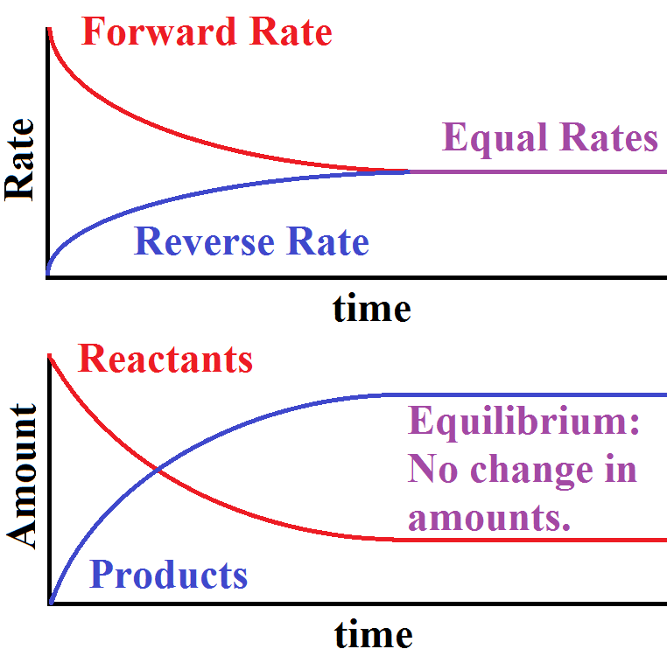



**Equilibrium**



**Equilibrium**



**Going to Completion**

When one of the products of a reaction is removed from the chemical equilibrium system as soon as it is produced, the reverse reaction cannot establish itself, and equilibrium is never reached. This is common in open systems which is why equilibrium cannot be established in open systems.

**Checking for Understanding**

1. What are three stresses that can upset the equilibrium of a chemical system?
2. Which stress or stresses change the value of the equilibrium constant?
3. What conditions can drive a reaction to completion?
4. What must be true of the reaction in order for pressure to have an effect on the equilibrium position?
5. Does the use of a catalyst influence the position of an equilibrium? Explain.

**Problems**

1. Given the following equilibrium equation: N2(g) + 2 O2(g) + 66.2kJ ⇌ 2 NO2(g). Predict the direction of equilibrium that will be favoured (forward, reverse, or neither) for each of the following changes.
   1. N2 is added.
   2. O2 is removed.
   3. The temperature is increased.
   4. The pressure is increased.
   5. A catalyst is used.
   6. NO2 is removed.
   7. The temperature is decreased.
   8. The system volume is increased.
2. For the system in question 6, how would the concentration of NO2 at equilibrium be affected by each change?
3. Given the following reaction for the formation of sulfur trioxide from sulfur dioxide and oxygen: 2SO2(g) + O2(g) ⇌ 2 SO3(g) + 198kJ. What conditions of temperature and pressure would maximize the concentration of SO3 at equilibrium? Explain your reasoning using Le Chatelier’s Principle.